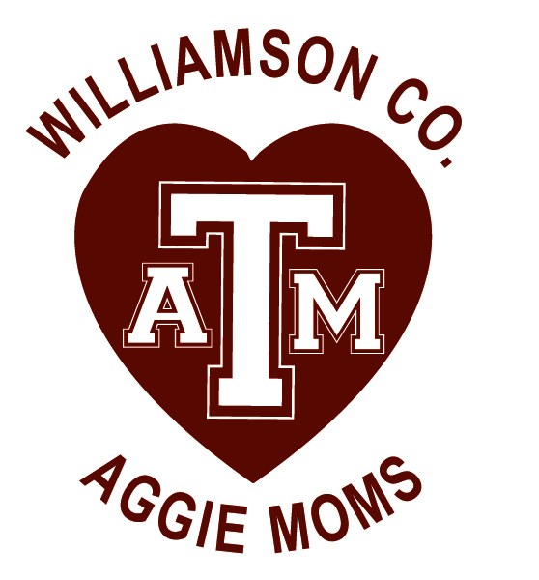
Williamson County Aggie Moms' Club
Bartlett, Bertram, Cedar Park, Coupland, Florence, Georgetown, Granger, Hutto, Jarrell, Leander, Liberty Hill, Round Rock, Taylor, Thrall
January 14, 2020
Community Room, Georgetown, TX
Minutes
- Call to Order 7:00 p.m. – President Melissa welcomed all and introduced our guest speaker, Carlos May, President Elect of WCAMC (Williamson County A&M Club). Carlos spoke of:
  - Fundraising, telling us about their Club Fish Fry that raised $40K in 2019. (This year’s is 6/5/20, 5-9 pm in San Gabriel park. He invited us to have a table at this event, to promote awareness of the Moms.)
  - Marketing
    - Happy Hour
    - Networking Breakfast
    - Networking Lunch
    - Pizza Night at Double Dave’s
    - Family Night on the 1st Wed. of every month
  - Their 12-12-12 program where they each try to recruit 12 Aggies to donate $12/month for 12 months.
Carlos shared that their club’s goal is to provide 8 full-ride scholarships. He suggested classy.com for info on holding a marathon and to combine that with a silent auction and raffle.
- Adjourned AT 9 pm

Upcoming Dates to Remember:
General Meeting Feb. 11, 2020 Community Room, Georgetown
Fundraiser TBD
Scholarship Reception Apr. 21, 2020 If we have our fundraiser

